MEDIA RELEASE

The Kindness Pandemic- Love Stories, Our Stories

360,000 members of The Kindness Pandemic Group have been invited to join a ‘Love Stories’ Campaign connecting vulnerable older people with younger family members

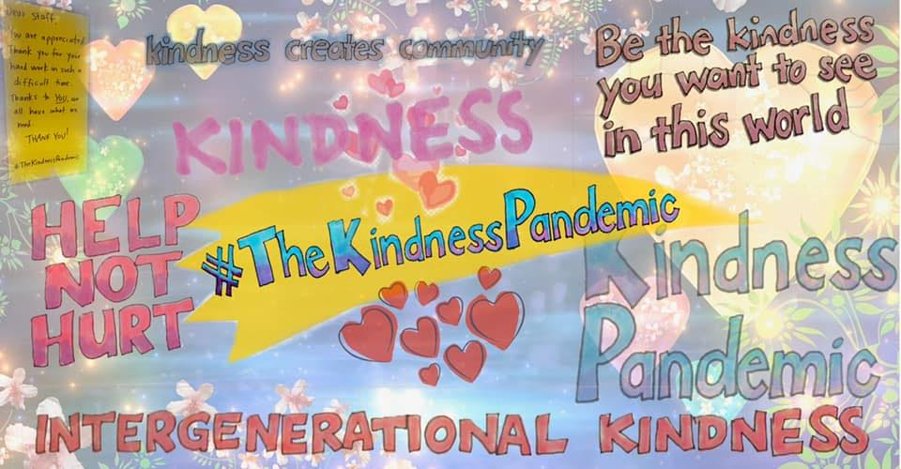

Download high res artwork here

The Kindness Pandemic is an Australian-based initiative promoting acts of kindness for people impacted by Coronavirus around the world.

The Kindness Pandemic was established on the 14th March with a Facebook Group that now has over 400,000 members from around the world sharing acts of kindness. In the past week the Group has shared campaigns to promote Random Acts of Kindness for staff in supermarkets and another online movement that focuses on bestowing kindness to health care workers.

The campaign, which is launched in collaboration with Playgroup Australia, Playgroup Victoria and most State and Territory Playgroup Organisations, aims to link vulnerable, isolated and anxious older people with their family and friends through messages from children and young people who love them. The messages will be sent electronically to older people - who are then invited to respond. The campaign aims to help reduce the anxiety, isolation and loneliness that older people may be experiencing, as well as engaging young people and forging intergenerational bonds. This exercise aims to enrich and bring greater meaning to our lives.

Members of the Kindness Pandemic Campaign are asked to share the Love Stories between older and younger people on the Facebook Group and on social media using the hashtag #TheKindnessPandemic

Campaign Founder Dr Catherine Barrett established the Kindness Pandemic out of concern for older people. Dr Barrett, who coordinates Celebrate Ageing, a social enterprise challenging ageism and building respect for older people, said:

“Ageism is so embedded in many cultures that we don’t even see it. Some of the discourses around the impacts of Coronavirus on older people have been ageist and this has contributed to the fears of older people.”

Quote about kindness: “Acts of kindness won’t make Coronavirus go away; but they may change our experience of it.”

Early feedback from parents is that the Love Stories Campaign will be embraced, particularly by those who have children at home and older parents who are isolated.

Quote from each PG State:

VIC: “Kindness restores the good in humanity. Finding acts of kindness and sharing them with those most in need, creates change, not only at an individual level, but to those of us who quietly suffer, who feel forgotten, who are having a bad day, who are unwell, who are worn out, who feel they have lost their way- who just need a reminder that they are loved. Kindness then transforms the greater good, the goodness in all of us. For children and for families, and our communities, in times like this, kindness reigns.”- Sinead Halliday, Playgroup Victoria

"We are thrilled to partner with the Kindness Pandemic at this extraordinary time. Love Stories gives us the chance to focus and be lost in what makes us feel real and normal connecting people on a level no virus will ever reach."- Danny Schwarz, Playgroup Victoria CEO

FOR FURTHER INFORMATION CONTACT

Dr Catherine Barrett
Email: director@celebrateageing.com
Phone: 0429582237
The Kindness Pandemic:
Webpage: thekindnesspandemic.org/olderpeople

Media enquiries:
Sinead Halliday, Media and Communications Coordinator, Playgroup Victoria
shalliday@playgroup.org.au | 1800 171 882 Ext 107

