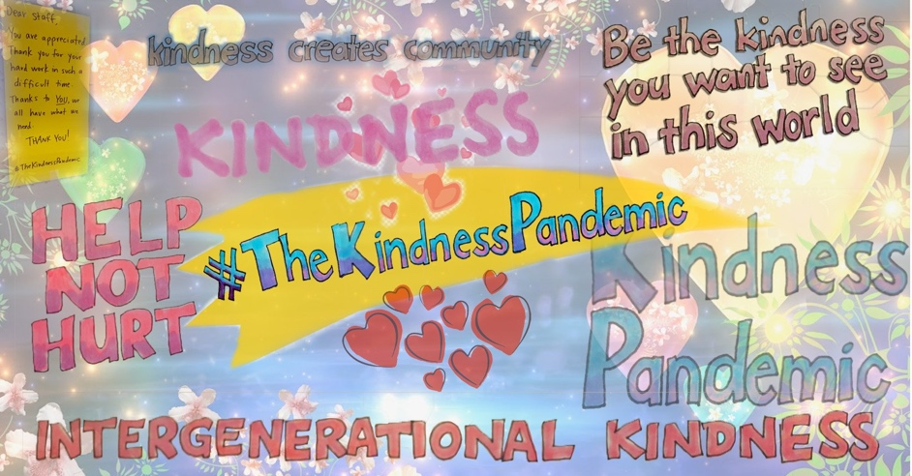

The Kindness Pandemic builds an International Network

Australian-based initiative #TheKindnessPandemic passes 400,000 members
and launches a global network of local groups supporting local communities

Thursday, 26 March 2020: An Australian-based initiative promoting acts of kindness, #TheKindnessPandemic, is helping people impacted by Coronavirus around the world.

The group was established on 14th March and a Facebook Group now has now over 400,000 members from around the world sharing acts of kindness. Groups members have posted that the group has restored their faith in humanity and promoted their mental wellbeing.

The project was established by Dr Catherine Barrett, who was concerned about the impact of the Virus on older people – and identified the need for kindness more broadly. Dr Barrett said

The Kindness Pandemic won’t make Coronavirus go away, but these acts of kindness can transform what we experience.

Dr Barrett wants to spread intersectional kindness, or kindness for people who are on the front lines including healthcare and supermarket workers and those that are marginalised (older people, people living with a disability, those who are immunocompromised). Group members are asked to share acts of kindness and the hashtag #TheKindnessPandemic

With interest from around the world there is an opportunity to embed the Campaign in local communities and establish a network on Groups around the Globe. In response, the Kindness Pandemic team are calling for towns, suburbs and cities around the world to set up their own local Kindness Pandemic Group. A template and guidelines for the Groups are provided on the Campaign website and A Facebook page has been established to list the groups to ensure people can find their closest group.

MORE INFORMATION
Contact Dr Catherine Barrett on 0429582237 or director@celebrateageing.com
The Kindness Pandemic Facebook Group: https://www.facebook.com/groups/515507852491119/
Webpage: https://www.thekindnesspandemic.org/local
Instagram: the.kindnesspandemic

