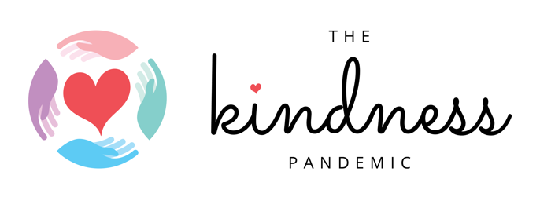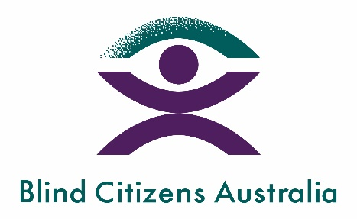

Campaign launched to support people who are blind or vision impaired during COVID-19

For people who are blind or vision impaired, COVID-19 presents unique challenges. Social distancing is difficult because guide dogs and white canes can't measure the required 1.5 metres, see the new markings on the floor for queuing or read the signs at shops about COVID-19 precautions. These difficulties mean some people who are blind or vision impaired may feel nervous going out and are spending more time at home than usual. There are some simple ways the whole community can help.
The #BeThatPerson campaign is a collaboration between Blind Citizens Australia and The Kindness Pandemic. The project encourages community members to approach someone who is blind or vision impaired - to introduce themselves and ask if they can help.
It also calls on community members to use 'Alt Text' to describe images on social media so they can be experienced by people who are blind or vision impaired.

The Campaign will be shared through the Kindness Pandemic Facebook group, which grew to over 500,000 members within two weeks of being established. The group spreads acts of kindness to people who are struggling with the consequences of COVID-19. Founder and Director of the Kindness Pandemic Dr Catherine Barrett said:

In our conversations with Blind Citizens Australia we have come to realise how simple it could be to reach out to people who are blind or vision impaired. These strategies are important for the current COVID-19 context – and beyond … the whole community needs to understand these strategies to encourage inclusiveness.

Blind Citizens Australia is the national representative organisation of people who are blind or vision impaired. BCA’s mission is to inform, connect, and empower Australians who are blind or vision impaired and the broader community. CEO of Blind Citizens Australia Emma Bennison said:

We are excited to partner with The Kindness Pandemic on this campaign which is about helping people who are blind or vision impaired build confidence to get outside again as COVID-19 restrictions are lifting. The #BeThatPerson campaign gives the public an opportunity to understand how to best assist people who are blind or vision impaired as they navigate the community during this time of physical distancing as well as highlighting small accessibility tweaks that can be made on social media to include us in the conversation.

More information
- Dr Catherine Barrett, Director of the Kindness Pandemic 0429582237
- Kathie Elliott, Strategic Development and Partnerships, BCA 0439 724304
- The Kindness Pandemic: https://www.thekindnesspandemic.org/blindness-kindness.html

